**ASSIGNMENT 4**

**AIM:**

a)Sort the data in ascending order using Selection sort and descending order by using Insertion sort.(Display pass by pass output)

b)Search a particular data using linear search

**OBJECTIVE:**

The objective of this assignment is to learn Selection sort and Insertion sort and be able to sort the data in ascending or descending order. Also in searching the specific data by linear search.

**THEORY:**

**Selection sort:**

In computer science, selection sort is a sorting algorithm, specifically an in-place comparison

sort. It has O time complexity, making it inefficient on large lists, and generally performs worse

than the similar insertion sort.

**Insertion sort:**

Insertion sort is a simple sorting algorithm that builds the final sorted array (or list) one item at

a time. It is much less efficient on large lists than more advanced algorithms such as quicksort, heapsort, or merge sort.

**Linear search:**

In computer science, a linear search or sequential search is a method for finding an element

within a list. It sequentially checks each element of the list until a match is found or the whole list

has been searched.

**CODE:**

#include<iostream>

using namespace std;

int main()

{

int n,a[20],i,j,temp,k;

cout<<endl<<"Sorting in ascending order by using selection sort"<<endl<<endl;

cout<<"Enter how many number you want to sort? ";

cin>>n;

cout<<"Enter numbers="<<endl;

for(i=0;i<n;i++)

{

cin>>a[i];

}

cout<<"acsending order using selection sort"<<endl;

cout<<"Passes";

for(i=0;i<n;i++)

{

j=i;

while(j>0&&a[j]<a[j-1])

{

temp=a[j];

a[j]=a[j-1];

a[j-1]=temp;

j--;

}

for(k=0;k<n;k++)

{

cout<<a[k]<<" ";

}

cout<<endl;

}

cout<<endl<<"sorted numbers are="<<endl;

for(i=0;i<n;i++)

{

cout<<a[i]<<"\t";

}

cout<<endl<<endl<<"Decsending order using insertion sort"<<endl;

for(i=0;i<n;i++)

{

j=i;

while(j>0&&a[j]>a[j-1])

{

temp=a[j];

a[j]=a[j-1];

a[j-1]=temp;

j--;

}

for(k=0;k<n;k++)

{

cout<<a[k]<<" ";

}

cout<<endl;

}

cout<<endl<<"sorted nubers are="<<endl;

for(i=0;i<n;i++)

{

cout<<a[i]<<"\t";

}

return 0;

}

**COMPLEXITY:**

Selection sort: O(n^2)

Insertion sort: O(n^2)

Linear search: O(n)

**OUTPUT:**

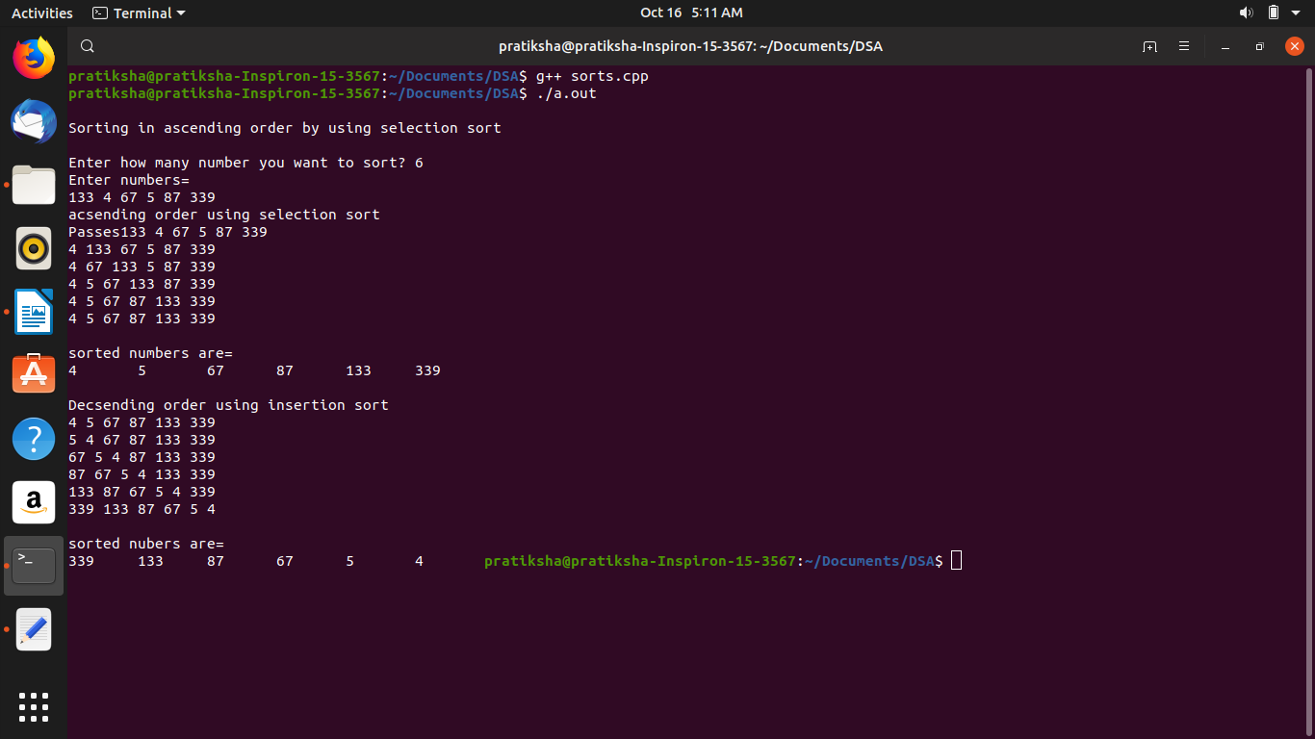

**CONCLUSION:**

We learnt how to sort the data by Selection sort and Insertion sort.